**Impact of Covid and War in Ukraine on economic variables**

During the past 2 years, two major events have trembled the economy of the modern world, the pandemics of Covid-19 and the ongoing war in Ukraine. Nonetheless, not only the tumultuous environment affected the worldwide economy but also the policies taken by the government to counter arrest it, and during this analysis, that fact will be reflected.

* **Economic Variables**
* **Exchange rate to Euro**
* **Unemployment**
* **Inflation**
* **Gasoline Price : USD per liter.**
* **Monetary Supply : M0,M1,M2 y M3.**
* **Sample**

This case-study consists of 22 countries divided in Non Eurozone countries, Eurozone countries, Turkey, Russia and the United States which data is evaluated from January 2019 to August 2022.

* **Non-Eurozone Countries**

Bulgaria

Czech Republic

Denmark

Croatia

Hungary

Poland

Romania

Sweden

Switzerland

Norway

United Kingdom

* **Eurozone Countries**

Germany

Estonia

Ireland

Spain

France

Italy

Netherlands

Portugal

* **Evolution of Inflation from 2019 to August 2022**

The chart shows that inflation rate maintained relatively stable until the first quarter of 2020 where it started dropping to deflation levels, likely due to the general lockdowns around the world and reduction of productions as consequence of Covid 19. However, the average inflation started going up in December 2020 surpassing 9%.

The chart shows that inflation rate maintained relatively stable until the first quarter of 2020 where it started dropping to nearly 0, likely due to the general lockdowns around the world and reduction of productions as consequence of Covid 19. However, the average inflation started going up in December 2020 surpassing 10%.

The chart shows that inflation rate gradually dropped to almost the half until the first month of 2020.However, the average inflation started going up since then, surpassing 15% in March 2022 and then gradually dropping since April 2022.

The chart shows that inflation rate gradually dropped to below 10% in September 2019. However, the average inflation went climbed gradually to previous levels since then until November of 2021, where the inflation rate started increasing rapidly up to 80% in August of 2022.

The chart shows that inflation rate maintained certain stability until February of 2022, when it dropped to nearly 0% in May of that year, likely due to the covid restrictions and lockdowns. However, the average inflation steadily went up to 8% in the second quarter of 2022.

The chart shows that inflation rate steadily increased throughout the period, highlighting Turkey with an exponential increase in November of 2022 and a considerable increase in Russia in February 2022.

Turkey presents the highest inflation rate of the research, with a big gap compared to the second highest inflation rate which is in Russia, and the third highest corresponding to the Non Euro Zone group in August of 2022.

* **Inflation forecast**
* **Non Eurozone countries**

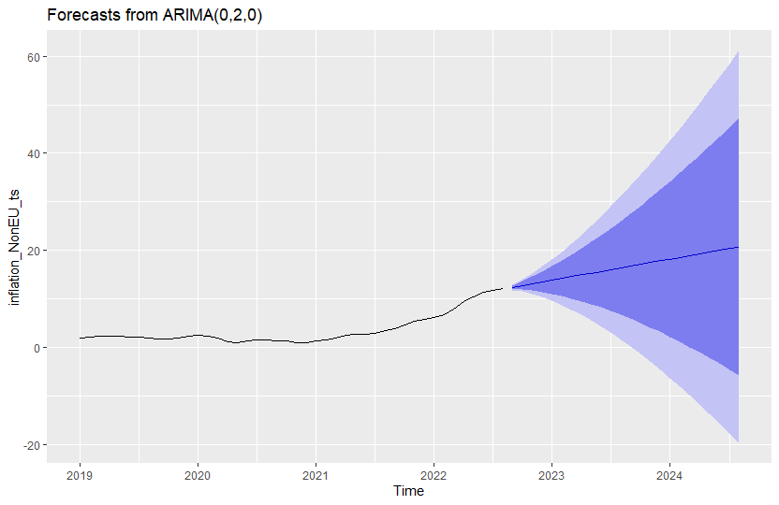

|  |  |
| --- | --- |
|  | Point Forecast |
| Sep 2022 | 12.43454545 |
| Oct 2022 | 12.79454545 |
| Nov 2022 | 13.15454545 |
| Dec 2022 | 13.51454545 |
| Jan 2023 | 13.87454545 |
| Feb 2023 | 14.23454545 |
| Mar 2023 | 14.59454545 |
| Apr 2023 | 14.95454545 |
| May 2023 | 15.31454545 |
| Jun 2023 | 15.67454545 |
| Jul 2023 | 16.03454545 |
| Aug 2023 | 16.39454545 |
| Sep 2023 | 16.75454545 |

The forecast shows that inflation rate might steadily increase in the next 2 years if the ongoing economic policies remain, surpassing the average of 15% by May 2023 and reaching a probable of 16,75% in September 2023.

* **Eurozone countries**

|  |  |
| --- | --- |
|  | Point Forecast |
| Sep 2022 | 11.35474796 |
| Oct 2022 | 11.76871892 |
| Nov 2022 | 12.07146354 |
| Dec 2022 | 12.40896445 |
| Jan 2023 | 12.95366566 |
| Feb 2023 | 13.34574159 |
| Mar 2023 | 13.1073632 |
| Apr 2023 | 13.51886408 |
| May 2023 | 13.90900304 |
| Jun 2023 | 14.2092436 |
| Jul 2023 | 14.600464 |
| Aug 2023 | 15.0488837 |
| Sep 2023 | 15.4201293 |

The forecast shows that inflation rate might steadily increase in the next 2 years if the ongoing economic policies remain, reaching up to 15,42% in September 2023, nearly the same estimation for Non Eurozone countries.

* **Russia**

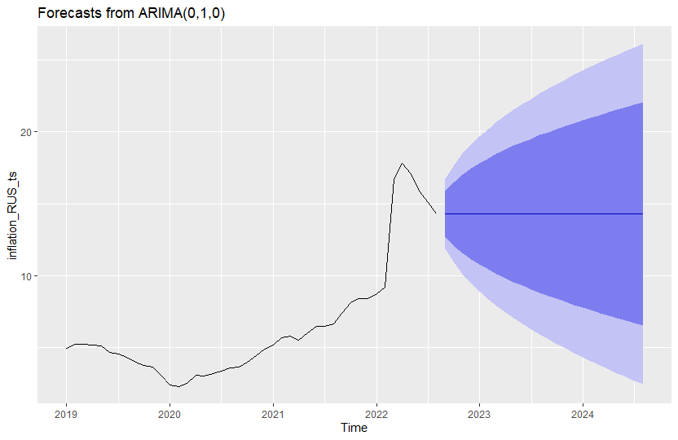

The forecast shows that inflation rate in Russia might maintain relatively stable during the next years or inclusively decline gradually to levels prior to 2022.

* **Turkey**

|  |  |
| --- | --- |
|  | Point Forecast |
| Sep 2022 | 83.58925 |
| Oct 2022 | 87.38366 |
| Nov 2022 | 91.17807 |
| Dec 2022 | 94.97249 |
| Jan 2023 | 98.7669 |
| Feb 2023 | 102.5613 |
| Mar 2023 | 106.3557 |
| Apr 2023 | 110.1501 |
| May 2023 | 113.9445 |
| Jun 2023 | 117.739 |
| Jul 2023 | 121.5334 |
| Aug 2023 | 125.3278 |
| Sep 2023 | 129.1222 |

The forecast shows that inflation rate in Turkey might aggressively increase in the next 2 year, even creating a future hyperinflation scenario, reaching nearly 130% in September 2023 and surpassing 150% in 2024. Turkey has the highest inflation estimation in this analysis, far away from estimations applied on other groups and countries.

* **United States**

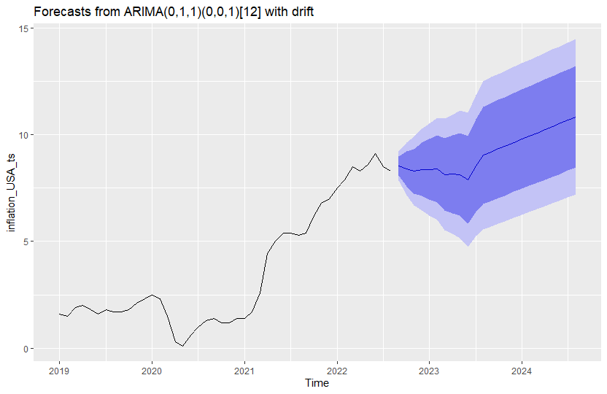

|  |  |
| --- | --- |
|  | Point Forecast |
| Sep 2022 | 8.527264 |
| Oct 2022 | 8.39728 |
| Nov 2022 | 8.281674 |
| Dec 2022 | 8.368744 |
| Jan 2023 | 8.365314 |
| Feb 2023 | 8.40384 |
| Mar 2023 | 8.134745 |
| Apr 2023 | 8.145605 |
| May 2023 | 8.139164 |
| Jun 2023 | 7.886103 |
| Jul 2023 | 8.540988 |
| Aug 2023 | 9.033405 |
| Sep 2023 | 9.185389 |

The forecast shows that inflation rate in the USA might gradually decline to 7,89% in June 2022, and then pushing back to 9,18% in September 2023, inclusively breaking the barrier of 10% by 2024.

* **Evolution of Unemployment from 2019 to August 2022**

The chart shows that the average of unemployment rate in eurozone countries has slightly varied throughout the study, notoriously increased since April 2020, likely due to the lockdown occasioned by the covid 2019 pandemic. However, the unemployment rate started dropping down since April 2021 to current levels of almost 6,5%.

The chart shows that the average of unemployment rate in non-eurozone countries has slightly varied throughout the study, notoriously increased since December 2019, and accelerated its pace in March 2022 likely due to the lockdown occasioned by the covid 2019 pandemic. However, the unemployment rate started dropping down since February 2021 to current levels below 4,5%.

The chart shows that the average of unemployment rate in the USA maintained stable until the first quarter of 2022 and notoriously increased in March 2020 surpassing 12% momentarily, likely due to the lockdowns occasioned by the covid 2019 pandemic. However, the unemployment rate started dropping down since April 2021 to current levels Below 5%.

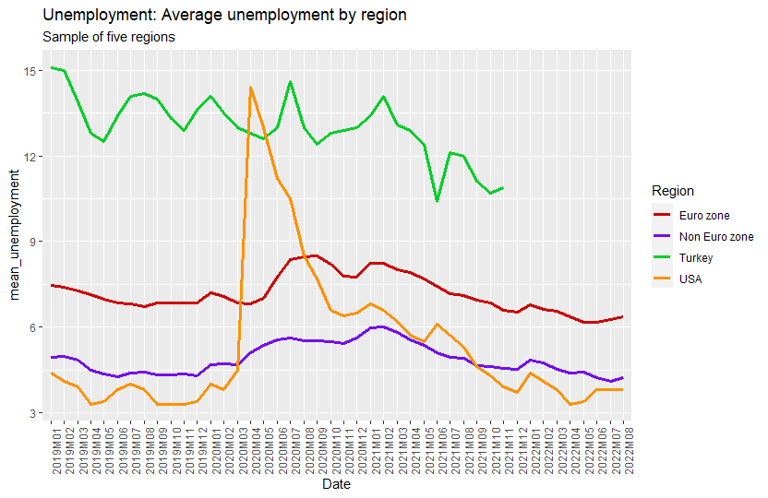

The chart shows that unemployment rate maintained relatively stable throughout the period, highlighting Turkey with the highest rate until November 2021, due to lack of data as Russia that was not analyzed, remarking that unemployment in the USA hiked up in April 2020.

During the 8 months study in 2022, the euro zone countries group have the highest unemployment rate on average, surpassing 6%, and being the USA the country with the lowest rate after a continuous decline since the big hike in April 2020.

* **Unemployment forecast**
* **Non Eurozone countries**

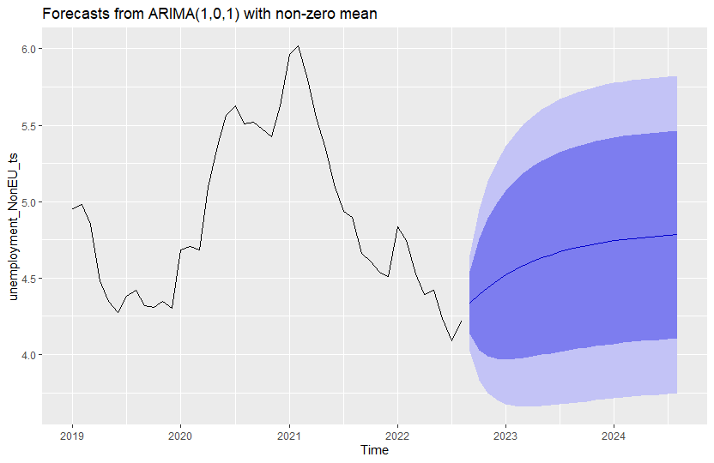

|  |  |
| --- | --- |
|  | Point Forecast |
| Sep 2022 | 4.336709107 |
| Oct 2022 | 4.391174513 |
| Nov 2022 | 4.439394464 |
| Dec 2022 | 4.482085116 |
| Jan 2023 | 4.519880504 |
| Feb 2023 | 4.55334196 |
| Mar 2023 | 4.582966448 |
| Apr 2023 | 4.609193946 |
| May 2023 | 4.632413982 |
| Jun 2023 | 4.652971417 |
| Jul 2023 | 4.671171565 |
| Aug 2023 | 4.687284734 |
| Sep 2023 | 4.701550234 |

The forecast shows that unemployment rate might maintain relatively stable in the next years, between 4 % and 5%, reaching 4,70% in September 2023.

* Eurozone countries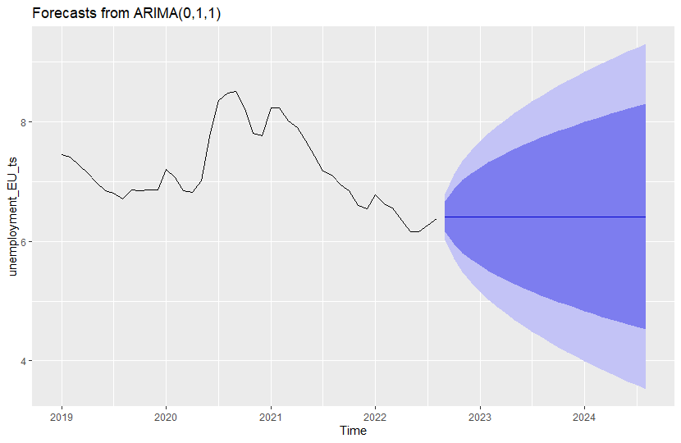

|  |  |
| --- | --- |
|  | Point Forecast |
| Sep 2022 | 6.411847546 |
| Oct 2022 | 6.411847546 |
| Nov 2022 | 6.411847546 |
| Dec 2022 | 6.411847546 |
| Jan 2023 | 6.411847546 |
| Feb 2023 | 6.411847546 |
| Mar 2023 | 6.411847546 |
| Apr 2023 | 6.411847546 |
| May 2023 | 6.411847546 |
| Jun 2023 | 6.411847546 |
| Jul 2023 | 6.411847546 |
| Aug 2023 | 6.411847546 |
| Sep 2023 | 6.411847546 |

The forecast shows that unemployment rate in eurozone countries might maintain relatively stable in the next years, between 6 % and 7%, reaching 6,4% in September 2023.

* **United States**

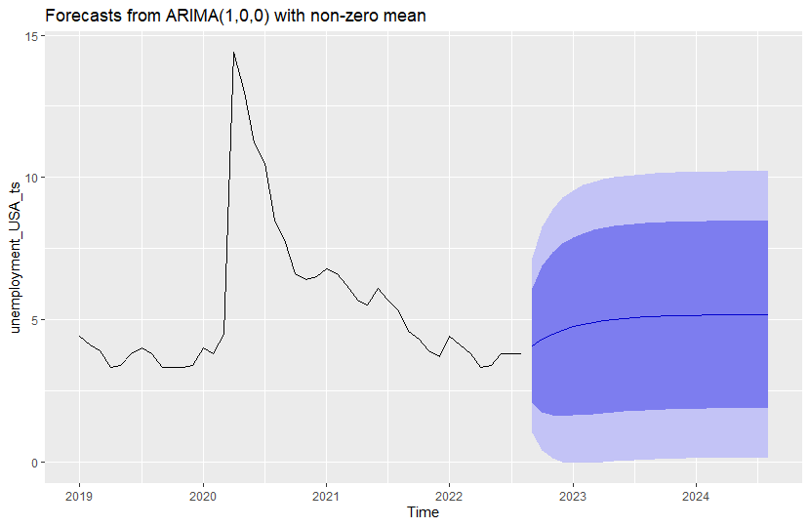

|  |  |
| --- | --- |
|  | Point Forecast |
| Sep 2022 | 4.087807969 |
| Oct 2022 | 4.315432313 |
| Nov 2022 | 4.49545805 |
| Dec 2022 | 4.637838543 |
| Jan 2023 | 4.7504458 |
| Feb 2023 | 4.839505714 |
| Mar 2023 | 4.909942278 |
| Apr 2023 | 4.965649828 |
| May 2023 | 5.009708352 |
| Jun 2023 | 5.044553783 |
| Jul 2023 | 5.072112674 |
| Aug 2023 | 5.093908715 |
| Sep 2023 | 5.111146978 |

The forecast shows that unemployment rate in the USA might steadily increase, surpassing 5% by May 2023, reaching up to 5,11% in September 2023.

* **Evolution of Gasoline price in USD from 2019 to August 2022**

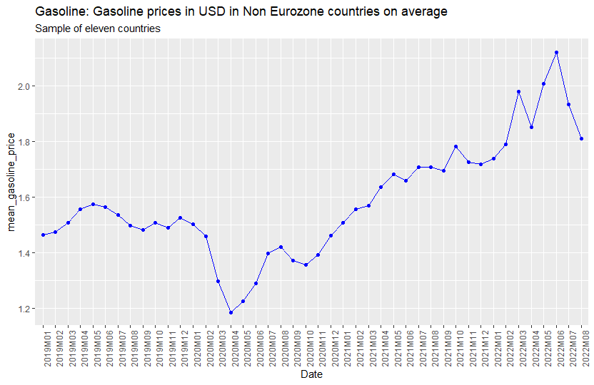

The chart shows that the average of gasoline price in non-eurozone countries has varied throughout the study, notoriously dropped in April 2020, likely due to the lockdown occasioned by the covid 2019 pandemic that generated a low consume. However, the prices steadily increased since April 2020 until June 2022, a new inflection point where prices started declining since then.

The chart shows that the average of gasoline price in eurozone countries has varied throughout the study, notoriously dropped in April 2020, likely due to the lockdown occasioned by the covid 2019 pandemic that generated a low consume. However, the prices steadily increased since April 2020 until June 2022, a new inflection point where prices started declining since then.

The chart shows that the average of gasoline price Russia has varied throughout the study, maintained relatively stable from 0.5 USD to 0,75 USD per liter until February 2022. However, the price dropped in March 2022, most likely due to the beginning of the war on Ukraine and notoriously increased up to 1 USD per liter in June 2022.

The chart shows that the average of gasoline price in Turkey has varied throughout the study, notoriously dropped in April 2020, likely due to the lockdown occasioned by the covid 2019 pandemic that generated a low consume. However, the prices steadily increased and maintained relatively stable until November 2021, where price started a rally surpassing 1.5 USD per liter and declining since then.

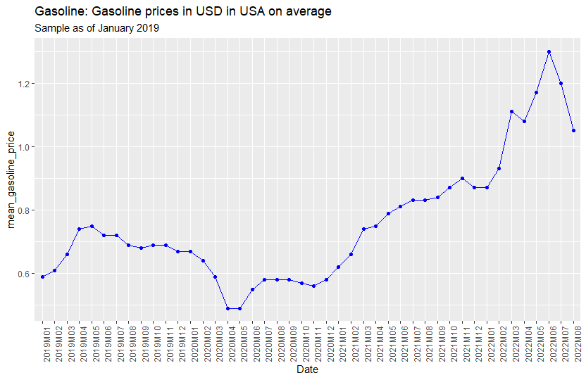

The chart shows that the average of gasoline price in the USA has varied throughout the study and maintained stable until April 2020 within a range from 0.5 USD to 0.7 USD per liter. However, the prices steadily increased since April 2020 until June 2022, surpassing 1,2 USD per liter, a new inflection point where prices started declining since then.

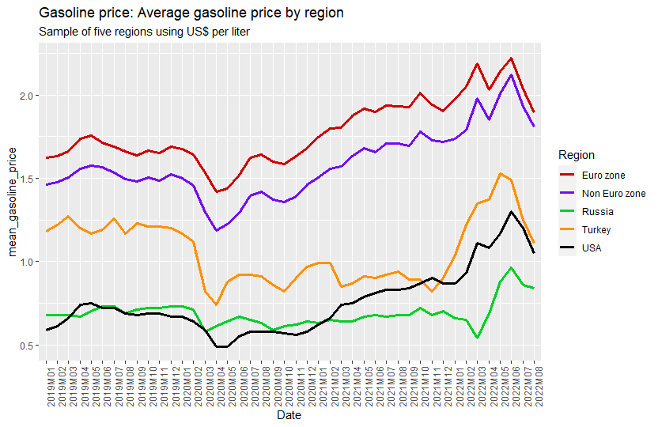

The chart shows that gasoline prices steadily increased throughout the period, highlighting Eurozone and Non-Eurozone countries by presenting the highest prices in the study, surpassing 1.5 USD per liter. However, prices in Russia maintained relatively stable until the first quarter of 2022, likely due to the war on Ukraine that occasioned a price increase.

During the study, June 2022 was the month with highest prices for every group, being an inflection point that started a decline of prices for the rest of months.

* **Correlation between variables.**
* **Non- Eurozone countries**

This chart shows a strong positive correlation between Inflation rate and Gasoline prices in Non-Eurozone countries, an increase of inflation may increase the gasoline price or vice versa.

This chart shows a strong negative correlation between Inflation rate and unemployment rate in Non-Eurozone countries, an increase of inflation may diminish the unemployment rate or vice versa.

* **Eurozone countries**

This chart shows a strong positive correlation between Inflation rate and Gasoline prices in Eurozone countries, an increase of inflation may increase the gasoline price or vice versa.

This chart shows a strong negative correlation between Inflation rate and unemployment rate in Eurozone countries, an increase of inflation may diminish the unemployment rate or vice versa.

* **Turkey**

This chart shows a strong positive correlation between Inflation rate and Gasoline prices in Turkey, an increase of inflation may increase the gasoline price or vice versa.

* **Russia**

This chart shows a moderate positive correlation between Inflation rate and Gasoline prices in Russia, an increase of inflation may cause an increase of the gasoline price at a certain level or vice versa.

* **United States**

This chart shows a very strong positive correlation between Inflation rate and Gasoline prices in the US, an increase of inflation may increase the gasoline price or vice versa.

This chart shows a moderate negative correlation between Inflation rate and unemployment rate in the US, an increase of inflation may diminish the unemployment rate at a certain level or vice versa.

* **Monetary Base and Poland analysis.**
* **Poland**

This chart shows the evolution of monetary supply since January 2019 that has steadily increased since then, highlighting the increase of M1 likely due to the pandemic stimulus where the currency in circulation and overnight deposits experienced a considerable increase, not precisely due to the monetary base (M0). Therefore, M2 and M3 also experienced a continuous increase throughout the period.

The chart shows that the exchange rate EUR/PLN has steadily increased throughout the period, surpassing 4.7 PLN per EUR in July 2022. However, the devaluation started its path since January 2020, the same month where the amount of M1 in Poland accelerated its increase.

This chart shows a strong positive correlation between EUR/PLN exchange rate and inflation rate in Poland, an increase of inflation may originate devaluation of exchange rate or vice versa.

* **Monetary Supply in United States and Eurozone**

This chart shows the evolution of monetary supply since January 2019 that has steadily increased since then, highlighting the increase of M1 likely due to the pandemic stimulus where the currency in circulation and overnight deposits experienced a considerable increase, specifically in the first quarter of 2020. Therefore, M2 and M3 also experienced a proportioned increase throughout the period that could have originated the inflation rally

This chart shows the evolution of monetary supply since January 2019 that has steadily increased since then, highlighting the outstanding increase of M1 likely due to the pandemic stimulus during the second quarter of 2020 where the number of deposits and other liquid deposits experienced a considerable increase. However, the increase of M2 was not proportionate to M1, therefore, the increase of M1 might be the cause that explains the inflation rally in the USA